10/15/2018
DIFFERENT LANYARDS
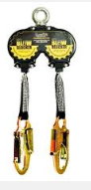
HAVE DIFFERENT STANDARDS
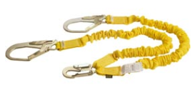

Should I Use an Energy-Absorbing Lanyard or a Self-Retracting Lanyard?

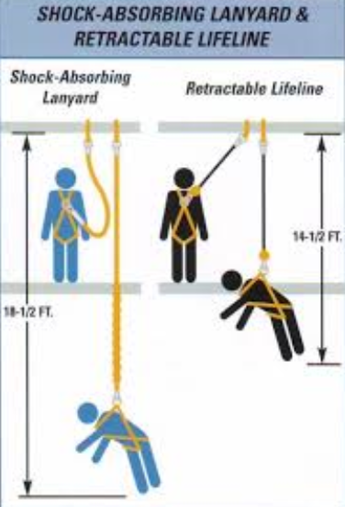
Similar to any fall protection equipment, choosing the right lanyard depends on the application and work environment. The basic rule is that people working below 17.5 feet should use a self-retracting lanyard (SRL) and those working above 17.5 feet can use an energy-absorbing lanyard or SRL. When using an energy-absorbing lanyard, the worker needs to be anchored at least 17.5 to 18 feet above the ground to ensure proper working clearances are achieved.

Generally, when above 17.5 feet, either an energy-absorbing lanyard or an SRL may be suitable. However, if mobility is a requirement, SRLs typically will present a wider range of movement while helping to minimize trip hazards as the lanyard always is pulled taut under retraction tension.

Both energy-absorbing lanyards and SRLs are available in web or cable and come in a variety of lengths. Web-style units may be best for indoor and less harsh environments, while cable-style lanyards may offer extra durability in abrasive or high-heat situations, such as roofing work and oil and gas applications.

