11/29/2019

GENERAL SAFETY
IF IT DOESN’T LOOK RIGHT DON’T RELENT
SAYING NOTHING IS GIVING SILENT CONSENT
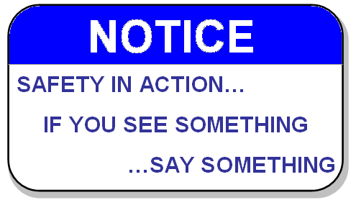
How would you define “Silent Consent”?

“Silent Consent” is allowing a condition to exist or allowing a practice to continue without speaking up or without acting on it. Every time we walk past something that doesn’t conform to a requirement or expectation and do nothing, we give silent consent which essentially creates a new acceptable and lower safety standard.

Consider a safety hazard that may be created by your actions and what about the people who see the hazard but do nothing about it? What new safety “standard” did they each set?

Could we find conditions here on our jobsite where a job was poorly executed which then created a hazard because no one acted to correct it? Are we giving Silent Consent to practices and conditions that we know do not conform to a requirement?

There can be many reasons given for looking the other way, e.g., “It was never a problem before”; “The job got done, didn’t it”; or “We didn’t want to create more work”. Some of these may even seem to have legitimacy. But can any of them legitimize an injury caused by inattention to a requirement?

Commit to acting when something doesn’t look right.

