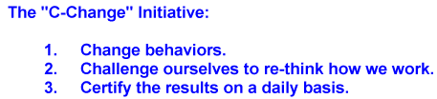

2/10/2020

FALLING OBJECT HAZARDS

Extra care is always needed when working on platforms and scaffolds, in aerial lifts, and at other elevated locations so that those working below are not put at risk.
Here are some things to know to help minimize the risk of falling object hazards.
- Make sure toe boards are fixed to all scaffolds and store loose materials, such as bolts, in containers so they are not unintentionally kicked off the platform.
- Use netting to cover platforms if toe boards don’t provide enough protection
- Avoid reaching over a guard rail while holding a tool. If it can’t be avoided, consider using a tool tether.
- Use a canvas bag and hand line to move tools and material to upper levels rather than carrying them.
- Don’t hold more than one object in your hand while working. For example, when working flanges or manways don’t hold a wrench in your hand while positioning bolts. Place the wrench down first so there are fewer things to juggle and to lose control of.
- Use sheeting to cover grating if small objects could fall through.
- Barricade the area below and put up tags to alert others of overhead work.

When working overhead ask yourself 3 questions…
1) What could possibly fall?
2) Where could potential falling objects fall through or from?
3) How can I prevent it from happening?

