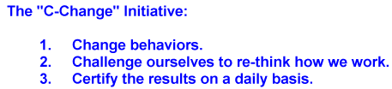

2/7/2020

Preventing Overexertion Injuries at Work

There are several ways that an overexertion injury can occur while working. The most common is caused when a person carries, lifts, pushes, or pulls something that is to heavy and it causes stress to occur on the joints in the body.

Reducing Overexertion Injuries in the Workplace
There are quite a few things you and others at work can do to reduce and prevent overexertion at work. By following the tips below you will be able to work safely:

- Take the time to position your body correctly before you lift or move anything. It only takes a few seconds to position yourself correctly in order to prevent an overexertion injury form occurring.
- Bend at the knees when lifting. These will reduce the strain that is put on your back when lifting heavy objects.
- Walk in a straight line and if possible avoid twisting your legs or torso to the side. Keep all parts of your body facing the same direction at all times.
- Have a plan before you lift. Know exactly where you are going and the route you are planning to take. Make sure there are no tripping hazards on your way and that the area you area heading to is clean.
- Keeping the object as close to your body as possible will help to greatly reduce the stress on your muscles.
- When reaching for something try to stand as close as possible. This will reduce the injuries that could occur such as stretching a tendon too far.
- If you feel the object is too heavy to lift alone you should immediately ask for help.
- You can reduce the need to bend by storing material on elevated platforms.
It is easy to prevent overexertion at work if you just take the time to stop and think before you complete the task at hand. Taking five minutes to make a safety plan is worth the time if it helps to prevent unnecessary injuries.

