03/9/2020
STOP AND HESITATE
WHEN YOU SEE BARRICADE TAPE
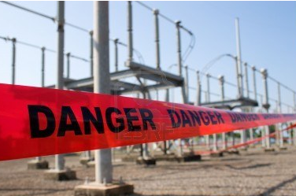
Who has the responsibility for a barricade?

Why do we use barricade tape?
Barricade tape is used to communicate an existing hazard or a potential hazard by controlling access / limiting access to a specific area. Barricade tape is only used as a temporary control, once the hazard is eliminated the tape can be removed. If a hazard extends over a period of time, look into a more weather stable type of barricade.

Examples of when barricade tape should be used for personnel exposure:
- Prepping equipment that requires depressuring, draining or venting that can potentially create a hazardous atmosphere. Things to take into consideration would be the actual hazard (i.e. toxic, flammable, etc.) wind direction and additional PPE requirements for the area.

- Work that requires opening equipment, breaking flanges, removing piping that can potentially create a hazardous atmosphere. Things to take into consideration would be the actual hazard (i.e. toxic, flammable, etc.) wind direction and additional PPE requirements for the area.

Who is responsible for installing, maintaining and removing barricade tape?

If your task is creating the actual or potential hazard you are responsible for the barricade. For a red barricaded area only the person that is responsible for that red barricaded area can authorize someone to enter. This allows the communication of the current condition and additional safety requirements that must be met to be in the barricaded area.

