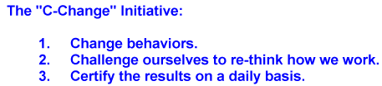

2/17/2020

Confined Spaces Safety

A confined space is considered any area that has restricted entrances and exits. They are not designed to be worked in for long periods of time. You should use confined space safety when working in pipes, manholes, underground pits, tanks and vaults. These are a few places that are considered confined spaces.
One of the biggest concerns of confined spaces safety is the flow of oxygen. Many areas that are labeled confined have a lack of proper ventilation. This makes it hard for carbon to exit and for new oxygen to replace it. Some confined places require a breathing mask and oxygen tank to insure you will not be harmed by toxic fumes.

6 Confined Spaces Safety Tips

- Always check the air quality before entering any confined space.
- Have proper ventilation or wear respiratory gear to help keep your breathing steady.
- Always have a hole watch outside of the confined space whose sole responsibility is to monitor entrants into the confined space
- Make sure you have a form of communication to contact your partner if you need help. A confined space radio with a dedicated channel is the best way for communicating.
- Wear proper safety gear when necessary. Gloves, hardhats, goggles and a full bodysuit are often used in confined spaces.
- Only workers trained in confined space safety are permitted to enter areas that are deemed confined spaces.

