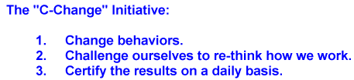

2/24/2020

EYE INJURY PREVENTION

One thousand eye injuries occur in American workplaces every day.
Why are these injuries occurring?
- Three out of five injuries happen because the worker was not wearing any eye protection at the time of the accident.
- About 40% of the injured workers were wearing some type of eye protection, but it was the wrong kind and failed to protect adequately. The leading cause in this category is the lack of side shields.
- Accident studies reveal flying or falling objects and sparks as the cause in 70% of eye injuries. Nearly 60% of the objects causing eye injury are smaller than a pin head.
- Nearly 20% of all eye injuries are caused by contact with chemicals. This includes splashing or chemicals being sprayed directly into the eye.
- 50% of the injured workers were employed in manufacturing. 20% were employed in construction.
What can we do to prevent these injuries?
First of all make sure you select the proper eye protection for the task. 94% of the eye injuries that occurred to workers wearing eye protection resulted from objects or chemicals going around or under the protector.
Second, make sure the eye protection you have selected fits properly and is clean. One of the leading reasons for workers removing or not wearing eye protection is the lens became dirty and they could not see what they were doing.
Nearly 20% of eye injuries happened to workers wearing face shields or welding helmets while grinding. Only 6% of the workers injured while wearing eye protection were wearing goggles.

CHOOSE THE BEST PROTECTION, MAKE SURE IT FITS AND KEEP IT CLEAN!

