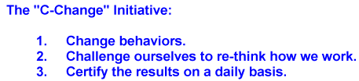

3/2/2020

Corona Virus Prevention

There is currently no vaccine to prevent coronavirus disease (COVID-19). The best way to prevent illness is to avoid being exposed to this virus. However, as a reminder, CDC always recommends everyday preventive actions to help prevent the spread of respiratory diseases, including:
- Avoid close contact with people who are sick.
- Avoid touching your eyes, nose, and mouth.
- Stay home when you are sick.
- Cover your cough or sneeze with a tissue, then throw the tissue in the trash.
- Clean and disinfect frequently touched objects and surfaces using a regular household cleaning spray or wipe.
- Follow CDC’s recommendations for using a facemask.
  - CDC does not recommend that people who are well wear a facemask to protect themselves from respiratory diseases, including COVID-19.
  - Facemasks should be used by people who show symptoms of COVID-19 to help prevent the spread of the disease to others.
- Wash your hands often with soap and water for at least 20 seconds, especially after going to the bathroom; before eating; and after blowing your nose, coughing, or sneezing.
  - If soap and water are not readily available, use an alcohol-based hand sanitizer with at least 60% alcohol. Always wash hands with soap and water if hands are visibly dirty.

